AMC501-T
Packing controller instruction manual

©2018 Shenzhen Accurate Measurement and processing
Technology Co ltd, copyright ownership.

Without permission from Shenzhen Accurate Measurement and processing Technology Co ltd, No unit or individual shall reproduce, disseminate, transcribe or translate into another language in any form or by any means.

As our products have been continuously improved and updated, we reserve the right to revise this manual without further notice. To do this, visit the company's website frequently to get timely information.
Company web site：http://www.szamp.com.cn/

This product carries out the standard:
GB/T 7724-2008< Electronic weighing meter > national standard
JJF1624-2017 Plan of Study for < Digital weighing display (weighing indicator)> form
JJG649-2016 digital weighing indicator（weighing Indicator）Verification regulation
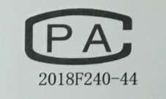

directory
1. Basic Information 1
1.1. Features and Specifications 1
1.2. Connection Port 4
1.3. Sensor wiring method 4
1.4. IO connection and definition 5
1.4.1. IO wiring diagram 5
1.4.2. IO default definition 6
1.5. Mounting Dimension 8
2. Main Interface 9
3. System Maintenance 12
3.1. Weight Calibration 13
3.1.1. Weight Calibration 14
3.1.2. Material calibration 15
3.1.3. Calibration Without Weights 16
3.2. Basic-wt-para-set 17
3.3. Tons-pack ctrl-para 19
3.3.1. Clamp bag and hook 19
3.3.2. Bracket lift 23
3.3.3. Inflatable and return air 27
3.3.4. Feeding process 28
3.3.5. Bag Function 30
3.3.6. Constant value process 32
3.3.7. Conveyor control 36
3.3.8. Level setting 39
3.4. Recipe parameters 41
3.4.1. Recipe number 41
3.4.2. Target 42
3.5. IO 43
3.5.1. IN Def. 43
3.5.2. OUT Def. 47
3.5.3. IO test 50
3.6. Batch and accumulation 53
3.6.1. Batch and accumulation 53
3.6.2. Historical data 54
3.7. Communications parameters 55
3.7.1. RS232 Set 55
3.7.2. RS485 Set 56
3.8. Admin pass-modify 57
3.9. System 58
3.9.1. Para. Reset 58
3.9.2. Date /time 58
3.9.3. Register 59
3.9.4. Backup Recover 59
3.9.5. Data import/export 60
3.10. Logic programming 62
3.10.1. Logical output sequence diagram 65
3.10.2. illustrate 67
4. Instructions of Process 69
4.1 Process of weighing ton package 69
4.2 Stop,pause and slow stop 72

Basic Information

Features and Specifications
The AMC501-T is a single-channel quantitative ton packet controller based on Chinese/English touch screen，support rises、drop control 、 Conveyor control、gas flushing pouch and deflate.AMC501-T adopts high color TFT touch screen, which supports input and display. It has a beautiful graphical interface, reasonable functional classification and layout. All these excellent features make AMC501-U very easy to use.
AMC501-T packaging controller has the following basic features：
●Terminal TFT highlighted color touch screen, input in Chinese and English and display in Chinese and English
●Perfect process control function，bracket lift、bag and conveyor Control
●Distributor accumulates functions，surpports USB export
●Up to 100,000 packaging historical data storage features，surpports USB export
●Setup data support for native backup and USB export
●Weighing channel: single channel
●Working voltage：DC24V
●Sensor：DC5V/4-wire and 6-wire system compatible
●Switch quantity：7 input /12 output
●Installation method：cubicle outfit（Panel mounting）
●Volume：203×149×50（Length * width * height，mm）

The detailed technical specifications are as follows：
Transducer Excitation | DC5V±10%/120mA Drive current/can receive eight Ω 350 specifications of the sensor
Adaptive Sensor Sensitivity | 2mV/V or 3mV/V
Input Signal Range | 0～15mV
Minimum Input Sensitivity | 0.5uV/d
Nonlinearity | 0.02%FS（3mV/V hour）
Zero Drift | ＜0.5μV/℃
Gain Drifting | ＜10PPM/℃
AD Rate | 960 Times/Seconds
Maximum Accuracy of Display | 1/100000
Product Accuracy Grade
Working Voltage | DC24V（18V～30V compatibility）
Product Power Consumption | ＜5W
Operating Temperature Range | -10℃~45℃
Storage Temperature | -20℃~60℃
Humidity | Within 90%RH（No Condensation）

Connection Port
The connection Port is shown:

Sensor wiring method

IO connection and definition

IO wiring diagram
IO wiring diagram is shown in the figure below (Take IN1、IN2、IN5 as example)：
The external circuit drives the input switch volume to meet two main points, as follows:
1. The external circuit shall be co-located with the controller
2. When the external circuit inputs low power, it means that the input is valid; otherwise, it means that the input is invalid.
IO wiring diagram is shown in the figure below (Take OUT6、OUT7、OUT8、OUT12 as example)：
The external circuit drives by the output switch volume should meet two main points, as follows:
1. The external circuit shall be co-located with controller
2. Low power when IO is effective
Note: The maximum driving capacity of each IO is 500mA. Please pay attention to the power of the load when connecting the load. When exceeding the driving capacity of the output outlet, it may cause damage to IO.

IO default definition
The connection port（IO port is the initial defined value）is described as follows：
interface | instructions | interface | instructions
24V+ | DC24V+ | 24V- | DC24V-
IO input
IN1 | I1. running | IN2 | I2. stop
IN3 | I3.pause | IN4 | I6. Clear alarm
IN5 | I8. clip/unclamp | IN6 | I9. hook on/off
IN7 | I10. raise/fall
IO output
OUT1 | Q1. running | OUT2 | Q2. stop
OUT3 | Q5. fast | OUT4 | Q6. med
OUT5 | Q7. slow | OUT6 | Q8. Fixed value
OUT7 | Q10. warning | OUT8 | Q11. Clamp
OUT9 | Q12. hook on | OUT10 | Q13. Rising（air）
OUT11 | Q20. inflate | OUT12 | Q21. deflate
Sensor interface
EX+ | Load Cell Excitation+ | EX- | Load Cell Excitation-
SN+ | Load Cell Sense+ | SN- | Load Cell Sense-
SI+ | Load Cell Signal+ | SI- | Load Cell Signal-
SHG | Load Cell Shielded Wire

Mounting Dimension
The image above is the bottom view of the product，data unit：mm
Recommended installation hole size：192mm×138mm

Main Interface
After the power start is completed, the main interface is entered, as shown in the figure below：
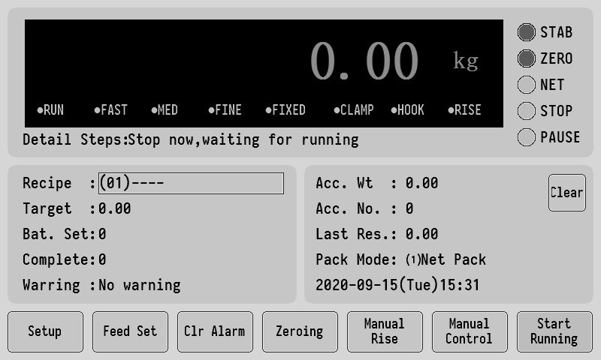
The top column shows the current weight value, as well as status indicators such as weight stability, zero, etc, and the detailed running steps of the controllerThe middle two columns show the following:
【recipe】The current recipe number and recipe name are displayed.
Click the display position of the formula number to enter the formula selection interface
【target】That is the target packaging weight of the current recipe used.
【set-bat】The target requires the number of packages to be packed.
【complete】The number of packages completed this time.
【warring】Displays the current alarm contents.
【Total cumulative weight】The total weight of the finished packaging
【Total cumulative packets】Total number of packages completed
Click theClear on the right to Clear the total accumulated data.
【Last res】Last packaging results.
【Pack-mode】Gross packing and net packing

At the bottom is the function button, which can set and operate some parameters. If the function button is in a grey state, it indicates that the function is not available (except for start running).
start running The gray color indicates the stop state.click on thestart running, if no error is reported, the system will start the packaging workflow.
Manual control can manually control Fast、Med、Slow、hook on、Conveyor start stop and so on, and there is a IO real-time status display.It can operate pause or slow stop in running
The interface is as follows:
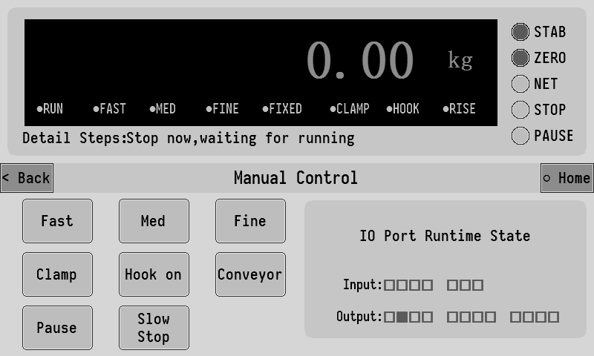
menual raise Click to manually control the rise and fall of the bracket.
zeroing Perform zero clearing for the current gross weight. When the button is gray, it means it is not available. For example, when running, it is gray.
clr alarm When there is an alarm, click the button to clear the alarm.
Feed set Click to enter the setting interface of relevant parameters under the current formula number .It includes target value, fast feed, med feed, slow feed andnear zero.

System Maintenance
Click setup on the main interface to enter the system maintenance interface, As shown in the following figure :(Default administrator password :000000)
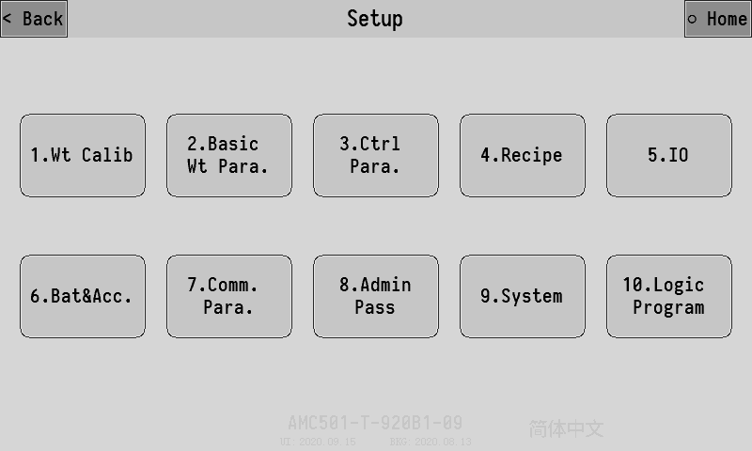
This screen lists all of the controller parameter Settings options
The model and software date of the controller are displayed at the bottom of the screen. Click on the bottom right corner English and Simplified Chinese can switch between Chinese and English display.
The following is a detailed description of each major item in system maintenance

Weight Calibration
The weight of new equipment needs to be calibrated before use. And set the system's parameters such as display units、 decimal separator 、Min seale mark and maximum range.
There are three ways of weight calibration, one of which can be chosen according to the actual situation.
- Wt Calibr(Weight Calibration)：Use weights or objects of known weight on the scale table for calibration.
- Material Clb(Material Calibration )：Add material directly to weighing bag or weighing bucket, and then weigh the actual weight of material to calibrate.
- No-wt Clb(Calibration without weights)：The voltage value and corresponding weight of direct input voltage value gain are calibrated.

Weight Calibration
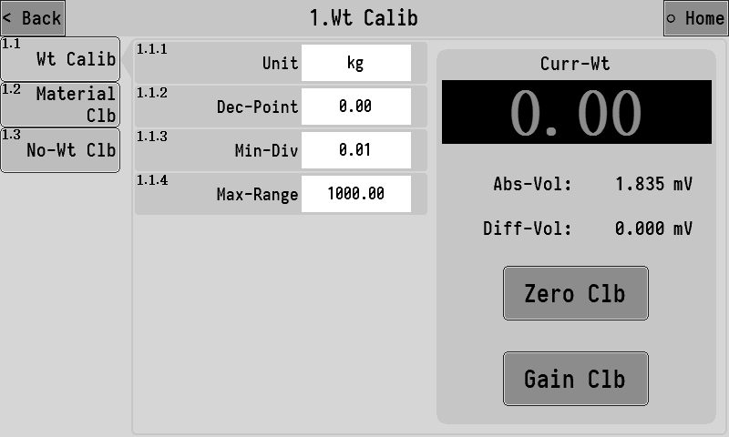
The absolute voltage shown in the right column is the current voltage value of the sensor. The normal range of this value is 0~15mV，If the value exceeds this range, the signal of the weight sensor is abnormal, check whether the sensor is damaged or the line connection is reliable.
The relative voltage is the difference between the current absolute voltage and the voltage value at zero point, amount to the value of the voltage generated by the gain weight.
The calibration process can be completed only by two steps of zero calibration and gain calibration. The operation is as follows:
- Empty the material, wait until the signal is stable (absolute voltage does not jump) click zero calibration，success will be marked zero success prompt.
- Put weights or objects of known weight on the weighing table, After the signal stabilizes (absolute voltage does not beat) click gain calibration,the input box pops up, enter the exact weight of the object and click Ok, when successful, the calibration gain will be indicated.
After the above two steps are completed, the weight calibration process will be completed, and the controller will display the accurate weight value on the scale.

Material calibration
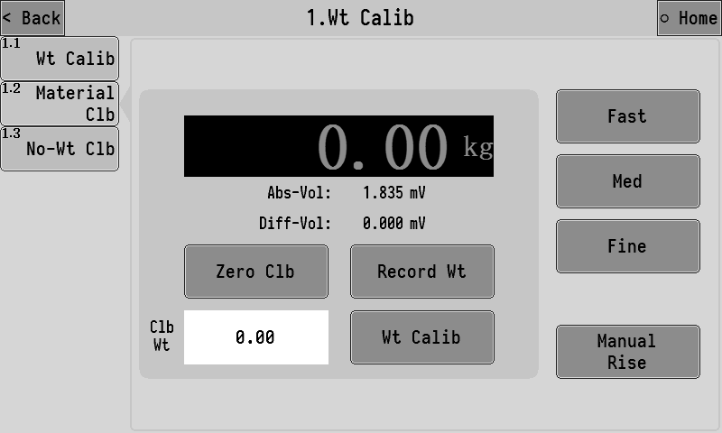
Material calibration can be directly added to the weighing bag or weighing bucket, the actual weight of the material is weighed after release for calibration.Operation is as follows:
- Empty the scale, after the signal stabilizes (absolute voltage does not beat) click zero calibration, success will be marked zero success prompt.
- Hang the bag on the hook and clamp the bag, Click Manual lifting bracket to lift the packaging bag,then can clickFast、Med、Slow can manually open and close the corresponding feeding device, add a certain amount of material to the package. After the signal stabilizes (absolute voltage does not beat), Click record weight to record the weight signal at this time.
- Then manually lowered the bracket，take off the package, put it on an accurate scale and weigh it against the weight of the package,and click【the weight】input box，the actual weight of the packaging bag obtained by input weighing is the completion of the material calibration process.

Calibration Without Weights
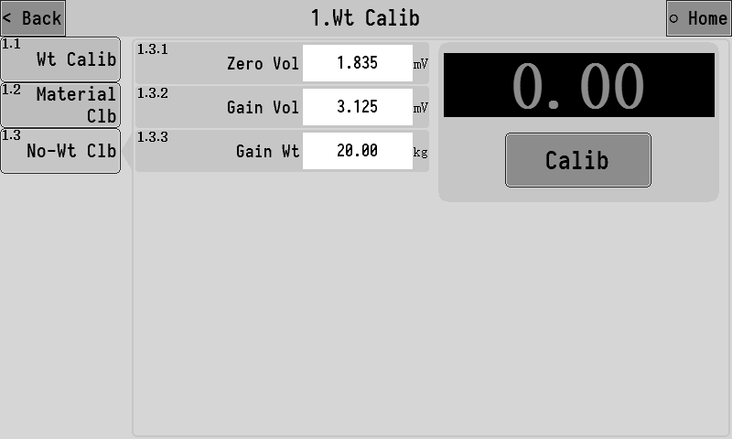
In this interface, can separately enter zero voltage, voltage gain, gain weight position，click calibration to complete the weightless calibration process

Basic-wt-para-set
Click the 2.Basic Wt Para button in the system maintenance interface to enter the setting interface of basic weighing parameters, as follows:
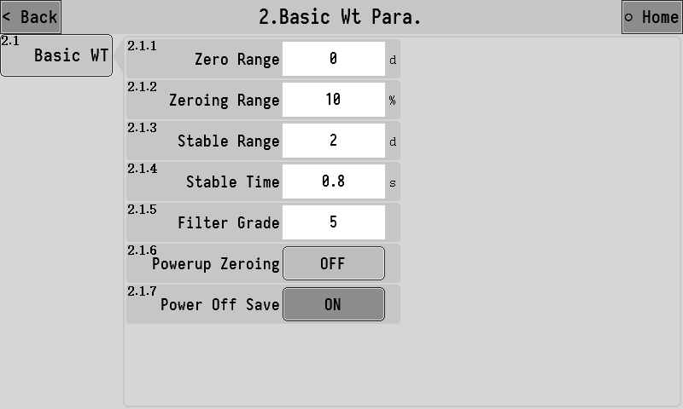
Parameter description list:
2.1.1 | zero range | It only works in the stopped state, when the weight value stabilizes within the positive and negative range of the set ×d (minimum dividing value), it will automatically clear to zero.
2.1.2 | zeroing range | When performing the zeroing operation, the weight must be less than or equal to “maximum range×zero range”
2.1.3 | Stable range | These two parameters work together to determine whether the weight is stable, If the difference between the maximum value and the minimum value is less than or equal to the stability range, then the weight value is considered stable at this time.
2.1.4 | Stable time
2.1.5 | Filter grade | Software digital filtering intensity level, according to the actual debugging effect of the equipment to set the appropriate filtering level parameters  0：The filtering effect is the weakest, the weight response is fast, and the anti-vibration effect is poor.  9：The filtering effect is the weakest, the weight response is fast, and the anti-vibration effect is poor
2.1.6 | powerup zeroing | After being turned on, the controller will automatically reset every time it is turned on.
2.1.7 | Power off save | After startup, if the power is accidentally dropped during operation, the controller will automatically save the parameters such as the tare of this operation. The next time the device is turned on, the upper left corner of the display screen will indicate "power down save", indicating the current data saved by power down. At this point, the "start" signal can be given to start the meter. The meter will be automatically peeled according to the lost electricity saved leather weight and continue the last feeding process.  If you want to refill, you can also give the " stop" signal to clear out the power to save data, and then "start" the refueling again.

Tons-pack ctrl-para
Click the button 3.Ctrl Paraon the system maintenance interface to enter the setting interface of Tons-pack ctrl-para setting, Follow functional and control procedures put parameters divided into 8 categories.

Clamp bag and hook
It can set the relevant functional parameters of bag and hook control. 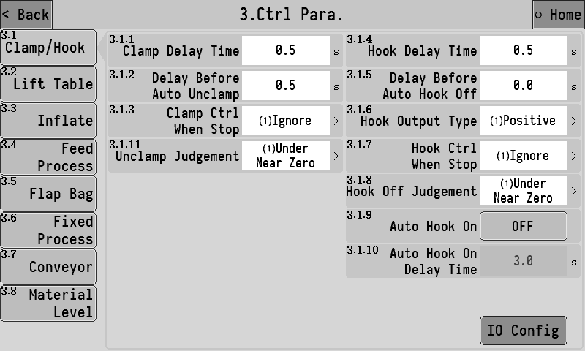
Function parameters of bagging:
3.1.1 | clamp delay time | After the signal of "clamp bag" is input, the action of "clamp bag" is considered to be completed after the delay of this time, it can continue the following process.
3.1.2 | delay bafore auto unclamp | When the judgment condition of loose bag is reached in running, start to loose the bag after delay.
3.1.3 | Clamp ctrl when stop | 1.[ uncontrolled]：After the stop signal is valid, the controller does not change the current clamping mechanism state.  2. [unclamp]：After the stop signal is effective, clamping mechanism resumes the unclamp state  3. [clip]：After the stop signal is effective, the clamping mechanism returns to the bag-clamping state
挂钩功能参数
3.1.4 | hook delay time | After the "hook" signal is input, the action of the hook is considered to be completed after the delay of this time, it can continue the following process.
3.1.5 | delay before auto hook off | After the decoupling judgement condition is reached, the decoupling begins after this time delay.
3.1.6 | hook output type | 1.[ Positive (effective hook)]：Hook output signal when valid hook, invalid decoupling  2.[ Reverse (invalid hook)] Hook output signal is valid when decoupling, invalid hook
3.1.7 | hook ctrl when stop | 1.[ uncontrolled]： When the stop signal is valid, the controller does not change the current state of the hook mechanism.  2. [hook off]：After the stop signal is effective, the hook mechanism resumes the decoupling state.  3. [hook on]：After the stop signal is valid, the hook mechanism is restored to the hook state.
3.1.8 | hook off judgement | 1. [ subzero value]：After the packaging is completed and the bracket begins to drop, the automatic bag release and decoupling will be started if the current weight is lower than the set "zero zone value".  2. [ falling over]：When the packing is completed and the brackets are lowered, the bag will be unpacked and unhooked automatically.
3.1.9 | auto hook on | When the function turns on, 【Automatic hook delay】will be started to delay after decoupling, and the hook signal will be automatically output after the delay time reaches.
3.1.10 | auto hook on delay time
3.1.11 | Loose bag judgment conditions | 1.[under near zero]：Began to decline after the packaging complete, stents, detect if the current weight is below the set of "zero value", began to loose bag automatically.  2.[ Stent descent complete]：Packaging is complete, after the stent decline, began to loose bag automatically.  3.[ manual]：Packaging is completed, after the stent decline, wait manual input "I8 clamp/unclamp" signal to unclamp bag.
Click enter IO configurationon the bottom right of the interface，can enter the IO input and output signal configuration interface related to the hook function,the corresponding input and output functions can be directly and quickly defined on the corresponding switch port.
For example, define the clip/unclamp input signal above the IN5 input IO, Click options，select IN5 from the popup options screen. After this operation and entering the IO input definition interface, For example, define the “clip/unclamp” input signal above the IN5 input IO, Click options，select IN5 from the popup options screen. After this operation and entering the IO input definition interface, The effect of defining the IN5 function as the “clip/unclamp” input signal is the same
Each of the following control parameters has a corresponding IO configuration interface, which will not be described one by one。

Bracket lift
Control the parameters related to the rise and fall of the weighing support.
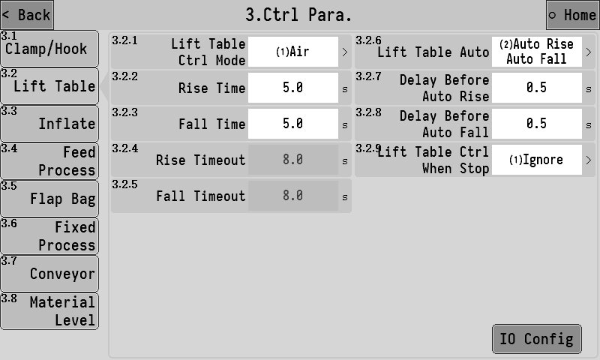
3.2.1 | Lift table ctrl mode | 1.[ air ]：The lifting of the support is controlled by pneumatic signal. The support rises when the "rising signal (pneumatic)" is effective.  2.[ Electric - double limit]：The lifting and lowering of the bracket is controlled by electric signals, and the upper and lower limit signals are required to input to the controller to determine whether the bracket is rising or falling in place.  3.[ Pneumatic - double limit]：The lifting of the support is controlled by pneumatic signal. The support rises when the "rising signal (pneumatic)" is effective, and falls when the "rising signal (pneumatic)" is invalid. And the upper and lower limit signals need to be input to the controller to determine whether the bracket is up and down in place.
3.2.2 | Rise time | After the lifting signal (pneumatic) is effective, the bracket begins to rise, and after this time, it is considered that the bracket has finished rising, so it can enter the next process.
3.2.3 | Fall time | After the rising signal (pneumatic) output is invalid, the bracket begins to decline. After this time, it is considered that the bracket has finished its descent and can enter the next process.
3.2.4 | Rise timeout | The bracket rise, and after this time, no upper limit signal of the bracket has been detected to be effective, then it is considered that the bracket goes through a timeout and gives an alarm.  Note: the timeout alarm is turned off when the timeout is set to 0.
3.2.5 | Fall timeout | The bracket decline, and after this time, the lower limit signal of the bracket has not been detected to be effective. Then, it is considered that the bracket goes into a timeout and gives an alarm.  Note: the timeout alarm is turned off when the timeout is set to 0.
3.2.6 | Lift table auto | 1.[ Automatic up automatic down]：After the controller starts, the bracket will start to rise automatically when the clamp and hook action are detected to be completed, and start to fall automatically after the packaging is completed.  2.[ Automatic up manual down] After the controller is started, when it is detected that the clamp and the hook action are all completed, the bracket will start to rise automatically. However, after the packaging is completed, the bracket cannot fall automatically.,need to manually entered "lifting/dropping bracket" signal to drop the bracket.  3.[ Manual ascent automatic descent] After the controller starts, when it is detected that the clam and hook action are all completed, the bracket needs to manually input the "lifting/dropping bracket" signal, the bracket will rise. After the packaging is completed, the bracket will automatically start to fall.  4.[closed]：After the controller starts and the clamp and hook action is completed, the "lift/drop support" signal needs to be manually entered, and the support will rise and complete the following process. After the packaging is completed, the "lift/drop support" signal needs to be manually entered ，the support will drop and complete the following process.
3.2.7 | Delay before auto rise | When the automatic rising function of bracket is turned on, after the action of bagging and hook is completed, the bracket starts to rise automatically after this time.
3.2.8 | Delay before auto fall | When the automatic descent function of the bracket is on, the feed is completed and the bracket begins to descend automatically after this time.
3.2.9 | Lift table ctrl when stop | 1.[ uncontrol]：After the stop signal is effective, the controller does not change the current state of the support mechanism.  2.[up]：After the stop signal is effective, the support mechanism reverts to the rising state.  3.[down]：After the stop signal is effective, the support mechanism reverts to the descending state

Inflatable and return air
The parameters related to packaging bag inflation and return air function can be set to inflate the bag before the packaging begins, and the return air valve can be opened after the completion of inflation to remove the air inside the bag during feeding.
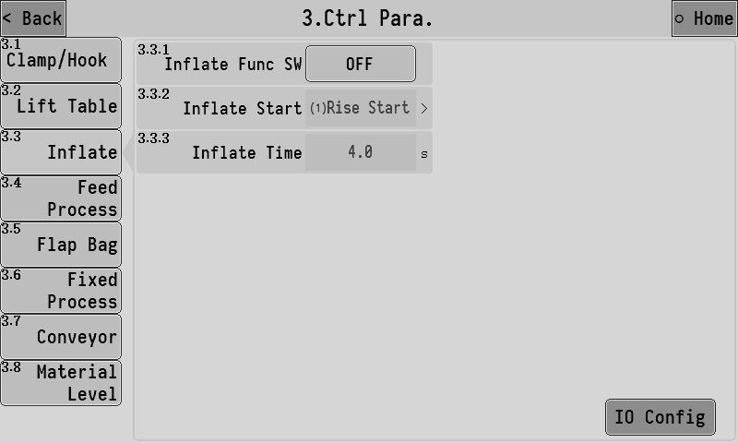
3.3.1 | Inflate Func SW | [opened]：Fill the bag with air before opening the package and open the return air valve after filling.  [closed]：Close the function.
3.3.2 | Inflate start | 1. [ When the ascent begins]：The filling process begins when the ascent begins.  2..[ After the ascent]：The filling process begins at the end of the ascent.
3.3.3 | Inflate time | Set the duration of the output of the "inflating" signal. After the inflation, the "air return" signal will start to be output, and the "air return" signal will be invalid until the end of feeding.

Feeding process
Set the related parameters of each function in the feeding process.
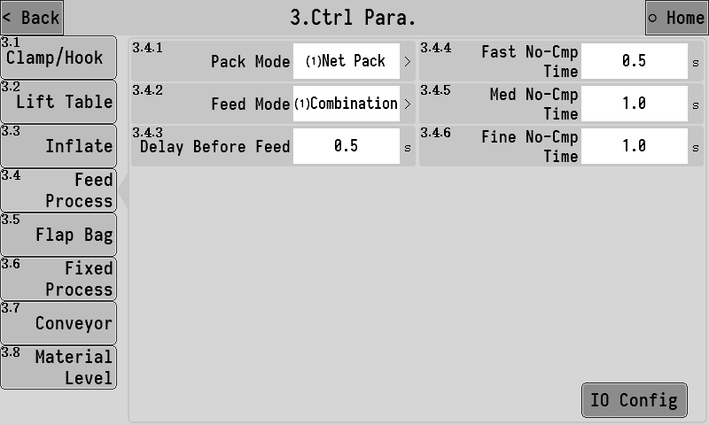
3.4.1 | Pack mode | 1. [net pack]：Before feeding, make sure to remove the skin and start feeding.  2. [ Gross weight packing]：Do not remove the leather before feeding, and start feeding directly.
3.4.2 | Feed mode | 1.[ combi-feed]：  fast：The output of fast, moderate and slow signal is effective  medium：Moderate and slow signal output is effective  Slow： small signal output effective.  2.[ Independent feeding]：  fast：effective in large output signal.  medium：feed signal output effective.  fast：time small signal output effective.
3.4.3 | Delay before time | The delay time before the start of feeding is completed.
3.4.4 | fast no-cmp time | The vibration elimination time at the beginning of the fast feeding, during which the fast feeding signal is always valid and not affected by the weight. After the time, it will be judged whether the weight reaches the amount before the fast feeding and thus ends the fast feeding.
3.4.5 | med no-cmp time | The vibration elimination time at the beginning of the moderate feeding, during which the moderate feeding signal is always valid and not affected by the weight. It is not until the end of the time that the weight reaches the lead amount of the moderate feeding to end the moderate feeding.
3.4.6 | fine no-cmp time | The vibration elimination time at the beginning of the slow feeding, during which the slow throw feeding is always effective and does not be affected by the weight.

Bag Function
Set the related parameters of the bagging function.
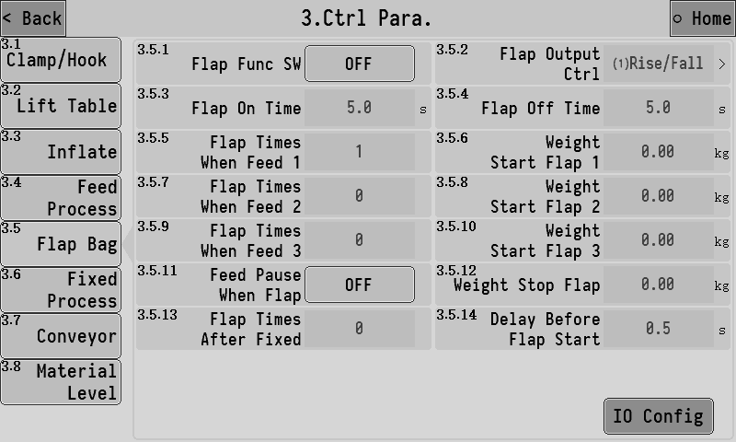
3.5.1 | Flap func SW | The main switch of pat function.
3.5.2 | Flap output ctrl | To set the function to be controlled when shooting the bag:  1. [ Bracket lift]：In the process of bagging, direct control of the lifting of the bracket to achieve the goal of bagging.  2. [ Clamp bag signal]：The bagging process outputs the bagging signal to control the separate bagging mechanism for bagging.  3. [ Bracket lifting and bagging signals]：In the process of bagging, the signal of bagging is also output while the control bracket is lifting.  Note: if the bagging process is not completed in the feeding process, the bagging process will be forced to end, so as to prevent the bagging action from affecting the feeding accuracy.
3.5.3 | Flap on time | In the process of bagging, the effective time of the signal output of bagging.
3.5.4 | Flap off time | In the process of bagging, the invalid time of the signal output of bagging.
pat times in feed function
3.5.5 | Flap times when feed 1 | Set the number of times you need to beat the bag the first time during the feeding process.
3.5.6 | weight start flap 1 | When the feeding weight reaches the set weight, the first feeding beat bag will be triggered.
3.5.7 | Flap times when feed 2 | Set the number of times to beat the bag for the second time during the feeding process.
3.5.8 | weight start flap 2 | When the feeding weight reaches the set weight value, the second feeding pat will be triggered.
3.5.9 | Flap times when feed 3 | Set the number of times to pat for the third time during the feeding process.
3.5.10 | weight start flap 3 | When the feeding weight reaches the set weight value, the third feeding pat will be triggered.
3.5.11 | Feed pause when flap | 1.[opened]：Not feed when pat.  2.[closed]：Feed when pat.
3.5.12 | Weight stop flap | If this parameter is not set to 0, the feeding weight reaches the set weight value to end the beating bag during the feeding process; if it is set to 0, this function does not work.
Fixed after pat
3.5.13 | Flap times after fixed | Set the number of times to beat the bag after the feeding is completed.
3.5.14 | Delay before flap start | Feed end , the delay time before the end of feeding and the start of the fixed value after beating bag function.

Constant value process
Set the related functional parameters of the process of setting the values after the feeding is completed.
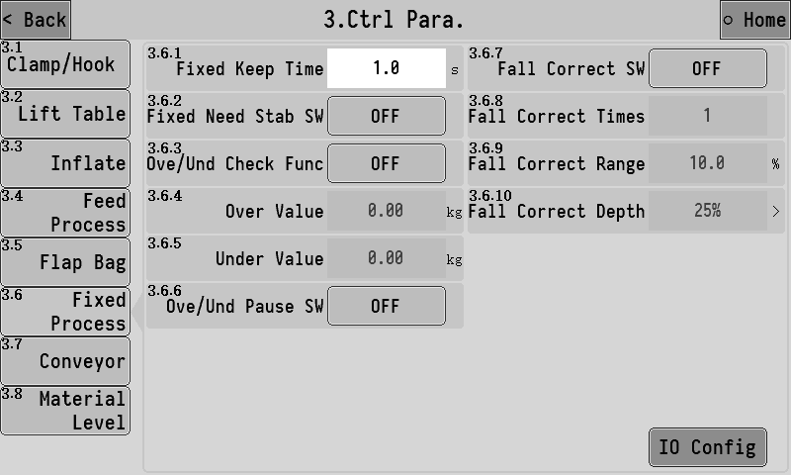
3.6.1 | fixed keep time | At the end of feeding, the functions such as result accumulation, error detection and error correction will be performed after waiting for this time.
3.6.2 | fixed need stab SW | 1. [opened]：At the end of the holding period, the weight needs to be stable for the next flow.  2.[closed]：At the end of the holding time, the weight does not need to be stable to enter the next process.
ove/und detect-func
3.6.3 | ove/und check func | Master switch for ove/und detect-func  1. [opened]：The feeding results will be ove/und test-time tested after each feeding.  2. [closed]：No fall and over/under detection is performed.  fall and over/under is the general term for overbalance or underbalance. In the packaging process, if the packaging result is higher than a certain range of the target value, it is considered to be out of tolerance, while if it is lower than a certain range, it is considered to be undertolerance, which is set according to the production demand.
3.6.4 | over value | In the ove/und detect, if the weight result is > target value + excess value, it is judged to be out of tolerance.
3.6.5 | under value | In the ove/und detect ,if the weight value < target value - under value, it will be judged as under difference.
3.6.6 | ove/und pause SW | When both the overbalance alarm switch and the overbalance suspension switch are on,if there is an over/under error, the controller will give an alarm and wait for the user to deal with it. At this point, the controller will continue to run after "clear the alarm", or it can give a "stop" signal to return to the stop state for processing.
In some cases, it may be necessary to use the drop correction function to improve the packaging accuracy. The drop correction function is to constantly revise the small drop drop value during the operation. The principle is as follows:
1. Target difference = the weight result -- target value
2. Target difference average = (target difference 1 + target difference 2 +... + target drop correction times)/drop correction times;
3. New small throw head = the last small throw head + the average of the target difference x the drop correction range;

3.6.7 | Fall correct SW | Main switch, for drop correction function.  1.[ opened]：The fine feed is calculated and corrected automatically after feeding.Fine feed.  2.[ closed]：No drop correction.
3.6.8 | Fall correct times | The average value obtained by averaging the drop value of the set number is taken as the basis of the drop correction
3.6.9 | Fall correct range | The percentage of the target value, when this drop exceeds the set range, this drop will not be included in the arithmetic average range
3.6.10 | Fall correct depth | Press the orange red button for 25%, 50%, , 100% optional, the range of each drop correction.

Conveyor control
Set related function parameters of conveyor control.
The controller supports the control of two section conveyor functions (conveyor 1 and 2). When starting, conveyor 1 and 2 will start to run at the same time. When the running time of conveyor 1 reaches the end, conveyor 2 will automatically stop. When the input of "Conveyor 2 in place signal" is detected to be valid, conveyor 2 will stop.
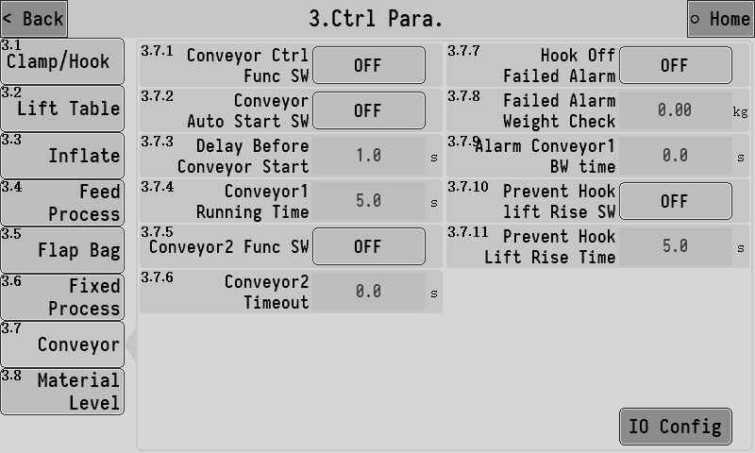
3.7.1 | conveyor ctrl func SW | Master switch of conveyor control .  1.[ opened]：Conveyor control is opens.  2. [closed]：The conveyor control is closed and the corresponding IO input and output of the conveyor are invalid.
3.7.2 | Conveyor auto start SW | 1.[ opened]：Automatic start conveyor after loosening bag and decoupling is completed.  2.[ closed]：The start and stop of the conveyor is completely controlled manually. It can customize "conveyor start stop" or "conveyor start stop & hang/hook" signal to control the conveyor action.
3.7.3 | delay before conveyor start | After the bag release and decoupling are completed, the conveyor will start to run after this delay time.
3.7.4 | conveyor 1 running time | The duration of the forward turning signal output of conveyor 1, after which the transmission process of conveyor 1 is considered to have been completed.
3.7.5 | Conveyor 2 func | 1.[opened]：Conveyor 2 function open.  2.[closed]：Conveyor 2 function closed.
3.7.6 | conveyor 2 timeout | If the time is not set to 0, the conveyor 2 will be forced to stop after continuous operation for longer than this time.
inadequacy alarm function
3.7.7 | Hook off failed alarm | 1.[ opened]：If the hook is not fully decoupled, the bag hangs the hook, and the conveyor will pull the weighing bracket to increase the weight. After the positive rotation signal of the conveyor is started, the controller detects the weight of the conveyor when it is running. If the weight is increased more than the set value when the conveyor starts, the alarm will be sent and the conveyor will be stopped.  2.[ closed]：Decoupling incomplete alarm detection is not performed.
3.7.8 | Failed alarm weight check | If the weight is increased more than the set value when the conveyor starts, the alarm will be sent and the conveyor will be stopped.
3.7.9 | Alarm conveyor 1 BW time | If the time is not set to 0, after decoupling the alarm, the controller will control the conveyor 1 to reverse and last the time.
Bracket rising anti - hook function
In order to prevent the bag hanging to the weighing bracket when the conveyor is running after decoupling, When the support lifting and anti-hook function is opened, the controller will control the support to carry out lifting action before the conveyor starts. Keep the bracket away from the bag, After the lifting process goes through the set time for the bracket to rise and prevent hook, then the conveyor is started to carry the bag away, and then the bracket begins to drop.
3.7.10 | Prevent hook lift rise SW | 1.[ opened]：The bracket lifting anti - hook function is on.  2.[ closed]：Bracket lift anti - hook function is closed.
3.7.11 | Prevent hook lift rise time | Before the conveyor starts, the bracket rises first and after this time, the conveyor starts again.

Level setting
Set the the level gauge input and feed related functional parameters.
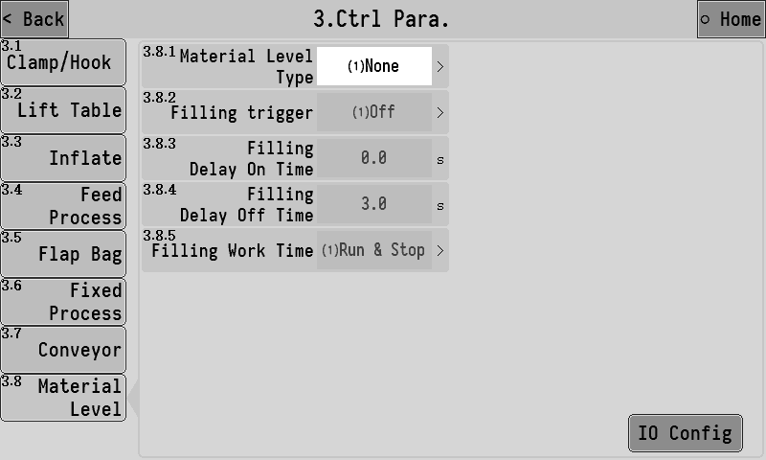
3.8.1 | Material level type | 1.[ No level gauge]：No level gauge.  2.[ Single down material level]：There is a feed level (feed level)  3.[ Upper and lower level]：There are 2 levels (feeding level and feeding level).  4.[ Single on material level]：There is a feed level (feed level)  Note: If the mode containing the blanking level is selected, feeding will not start if the blanking level signal input is invalid.
3.8.2 | Filling trigger | 1.[closed]：Turn off the feed output function.  2.[ Down blanking level trigger]：Down trigger feeding function when blanking level input is invalid.  3.[ Up feeding level trigger]：Up trigger feeding function when feeding level input is invalid.  Note: When the feed level mode is set to [up and down feed level], the feed function will continue until the feed level signal is effective.
3.8.3 | Filling delay on time | After the feeding function is triggered, the feeding signal will be output after the delay of this time.
3.8.4 | Filling delay off time | After the end of feeding, the feed signal output should be closed after the delay of this time.
3.8.5 | Filling work time | 1.[ Feed both when running and when stopping]。  2.[ Feed only run]。

Recipe parameters
The controller has 20 sets of formula parameters for setting. Users can set the commonly used formula parameters in advance and switch to the corresponding formula when using.

Recipe number
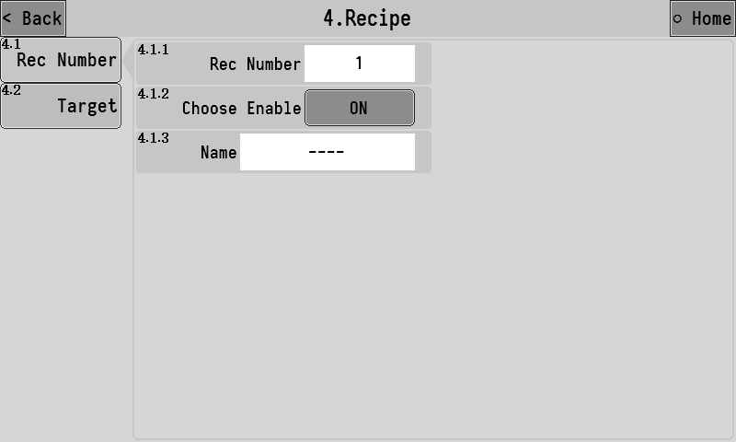
4.1.1 | Rec number | Sets the currently used recipe number.
4.1.2 | Choose enable | After it is opened, when the recipe number is selected by clicking the recipe number position on the main interface, the recipe will be in an optional state.
4.1.3 | Name | The name of the formula can be entered for easy memory. After setting, the corresponding recipe name will be displayed in the recipe number position on the main interface.

Target
This interface sets the target value of the formula number and other formula parameters.
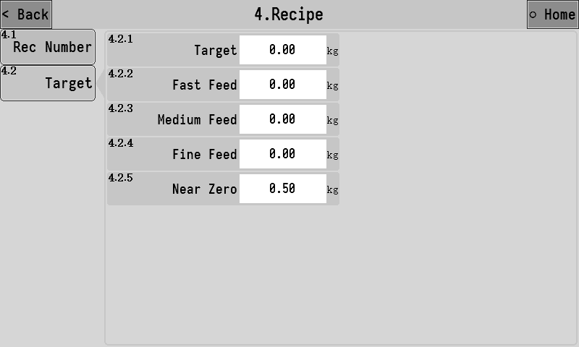
4.2.1 | Target | Set the target weight for the package.
4.2.2 | fast feed | When feeding,the weight value≥ target -fast feed, close the fast feeding;
4.2.3 | med feed | When feeding,the weight value≥ target -med feed, close the moderate feeding
4.2.4 | slow feed | When feeding,the weight value≥ target -slow feed, close the slow feeding
4.2.5 | near zero | When 【3.1.8 the judgment condition of loose bag and decoupling】is set as "lower than zero area value", it is used to judge the start of loose bag and decoupling action.

IO
The functions corresponding to the input and output of switching variables can be defined. And the IO test function can be used to test whether the external switching volume circuit is normal.

IN Def.
Define the corresponding functions of switch input ports IN1~IN7. Click the input port of the switch to be set, and select the function to be defined in the popup box.
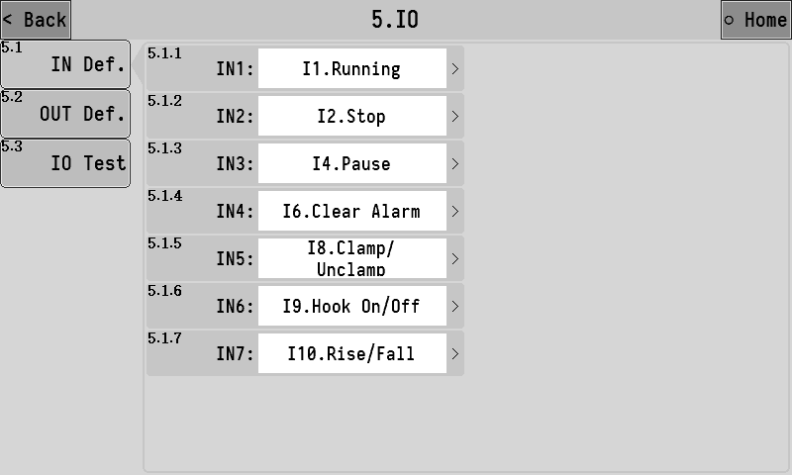
The list of functions available for switching input is as follows:
Function number | Function name | describe
I0 | None | No functional definition.
I1 | Running | Start running.
I2 | Stop | Stop running.
I3 | Slowly stop | Enter the slow stop process, that is, after the completion of this packaging automatically stop running.
I4 | Pause | Pause the operation. You can continue after you give the start signal again.
I5 | Zeroing | Perform a zeroing operation.
I6 | Clear alarm | Clear the alarm status.
I7 | Change Rec. | Valid once, automatically switches to the next recipe with a non-zero target value.
I8 | Clip/Unclamp | Clamp/unclamp operation input signal.
I9 | Hook on/off | Hook on/hook off input signal.
I10 | Raise/fall | The lift/drop support operates the input signal.
I11 | manual fine | Turn slow on when it's active, turn slow off when it's active again.
I12 | manual med | Turn med on when it's active, turn med off when it's active again.
I13 | manual fast | Turn fast on when it's active, turn fast off when it's active again.
I14 | Clr Total Acc | Clear the total accumulative data.
I15 | Clr Rec Acc | Clears the current recipe backlog data.
I16 | Upper level | Up feeding level detects input signal.When effective, it is considered that the material has reached the loading level.
I17 | Lower level | Blanking level detects input signal.When effective, it is considered that the material has reached the cutting level.When invalid, it is considered that the material is lower than the cutting and is in the state of material shortage.
I18 | Raise limit | Upper bracket input signal.When effective, the bracket is considered to have run to the upper limit position.
I19 | Fall limit | Lower bracket input signal.When effective, the bracket is considered to have run to the lower limit position.
I20 | Running/Stop | Start running when valid.Stop running when invalid.
I21 | Running/slowly stop | Start running when valid.When invalid, enter the deferment process.
I22 | Running/pause | Start running when valid.Enter the suspended state when invalid.
I23 | manual fine(lvl) | Open the slow when it is valid, close the slow when it is invalid.
I24 | manual med(lvl) | Open the med when it is valid, close the med when it is invalid.
I25 | manual fast(lvl) | Open the fast when it is valid, close the fast when it is invalid.
I26 | Clamp OK | This signal can be used when the clamp device has in place switch detection. When effective, it is considered that the clamp action has been completed.
I27 | Conveyor start | The conveyor starts when effective, and stops when effective again.
I28 | Conveyor & Hook on/ off | It is equivalent to giving "conveyor start stop" signal and "Hook on/off" signal at the same time
I29 | Conveyor 2 in position | Conveyor 2 in place to detect the input signal.

OUT Def.
Define the corresponding functions of switch output OUT1~OUT12. Click the switch output outlet to be set, and select the function to be defined in the pop-up option box.
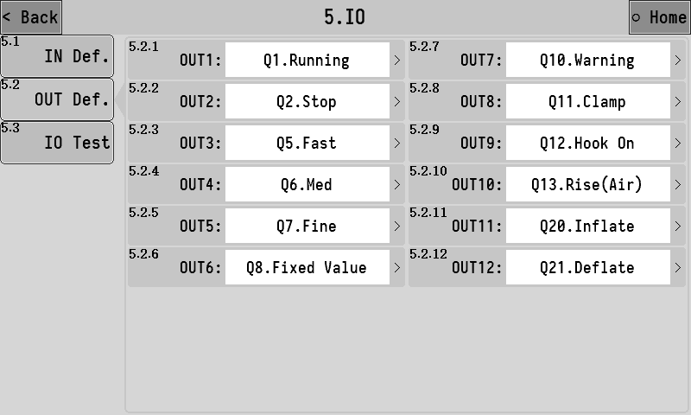
The list of functions available for switching input is as follows:
Function number | Function name | describe
Q0 | None | No functional definition.
Q1 | Running | The output is valid while running.
Q2 | Stop | The output is valid when the state is stopped.
Q3 | Slow stop | The output is valid while in the pause process.
Q4 | Pause | The output is valid while in the paused state.
Q5 | Fast | Fast feeding control signal.
Q6 | Med | Medium speed feeding control signal.
Q7 | Fine | Slow feeding control signal.
Q8 | Fixed Value | When the feeding is completed, the output is valid, indicating that the feeding has been completed at present, and the duration can be set [3.6.1 Fixed retention time].
Q9 | ove/und | The overunderdifference function is on. When the overunderdifference alarm occurs in the feeding result, the output is effective.
Q10 | Warning | The output is valid when the controller has alarm.
Q11 | Clamp | Bag clamping mechanism control signal, when effective bag clamping, when invalid bag loosening.
Q12 | Hook On | Hook mechanism control signal, the output state of the signal is set by parameter [3.1.6 logic type of hook output signal].
Q13 | Rise(air) | Pneumatic support rising control signal.Scaffolds rise when effective and fall when ineffective.
Q14 | Rise(motor) | Rise control signal of electric bracket.
Q15 | Fall (motor) | Drop control signal of electric support.
Q16 | Flap Bag | Clamp function output signal.
Q17 | Starving | Lack of material state output signal.When the signal input of "blanking level" is invalid, it is in the state of material shortage.
Q18 | Filling | Feed control output signal.When the signal is valid, start the feeding device to feed the material into the storage hopper.
Q19 | Batch complete | The signal output is valid after the batch is completed.
Q20 | Inflate | Inflatable output signal. | The functions of inflation and return air can be described in section 3.3.3.
Q21 | Deflate | Return air output signal.
Q22 | Conveyor 1 FW | Conveyor 1 positive turn control signal.
Q23 | Conveyor 1 BW | Conveyor 1 reverse control signal.
Q24 | Logic 1 | Logic programming 1 function output signal.
Q25 | Logic 2 | Logic programming 2 function output signal.
Q26 | Logic 3 | Logic programming 3 function output signal.
Q27 | Logic 4 | Logic programming 4 function output signal.
Q28 | Logic 5 | Logic programming 5 function output signal.
Q29 | Conveyor 2 run | Operation control signal of conveyor 2.

IO test
IO test is a function used to test whether the input switch quantity and output switch quantity work normally. The interface is shown as below: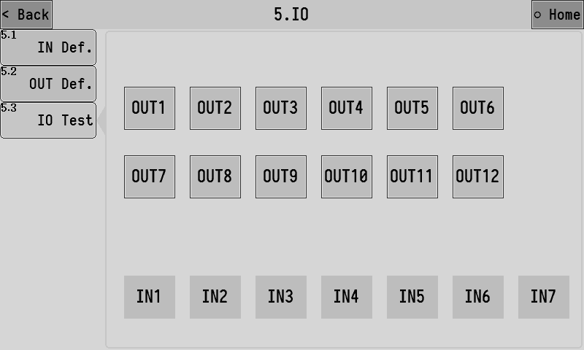
OUT Def：
The OUT1~OUT12 buttons are used to test the output function of the switch volume. Grey indicates that the output of switching quantity is invalid, while green indicates that the output of switching quantity is valid.
Such as:
The output outlet of OUT3 is connected to the relay. To test whether the output of OUT3 is normal, click OUT3 button to switch the output state to be effective. If the line is normal, it can be observed that the connected relay on OUT3 is pulled in, and then click OUT3 button again to switch the output state to be invalid.
IN Def：
IN1~IN7 is used to test the input function of switching volume. Grey indicates that the switching input is invalid, while green indicates that the switching input is valid.
Such as:
A button switch is connected to the IN1 input port. To test whether the button switch is normal, you can manually press the connected button. If the line is normal, you can observe that the IN1 indicator light turns green. After releasing the button, if the line is normal, the IN1 indicator will be observed to turn gray.

Batch and accumulation
View the accumulated and historical data of the controller.

Batch and accumulation
Check the total accumulated value of the control and the corresponding formula accumulated value to set the number of run batches. The interface is shown as follows:
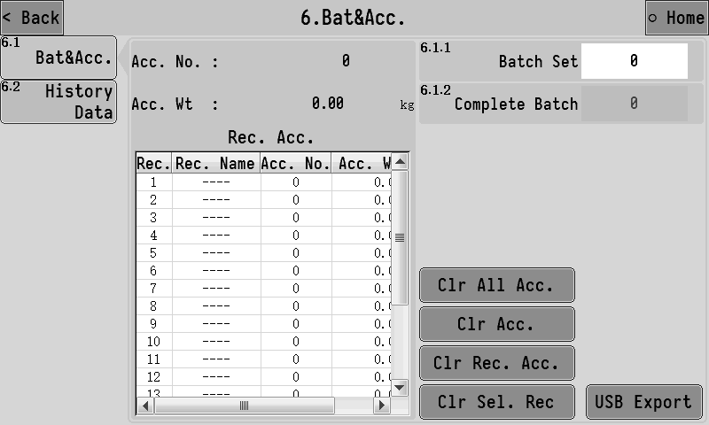
6.1.1 | batch set | Used to set the number of packages. When the number of runs reaches the number of batches set, the packaging process will be stopped and the alarm will be alerted. Turn off the function when set to 0.
6.1.2 | Complete batch | If batch number is set, this item displays the number of batches currently completed.
When the controller is inserted into the USB flash disk, the accumulative data file can be exported to the USB flash disk in CSV format.

Historical data
View the packaging history, including items such as the cumulative number of packages, dates, results, recipe parameter Settings, and packaging time.
The controller can store up to 100,000 pieces of historical data. When the storage space is full, The old data will be stored and overwritten again from sequence number 1.
When the controller is inserted into the USB flash disk, the historical data file can be exported to the USB flash disk in CSV format.
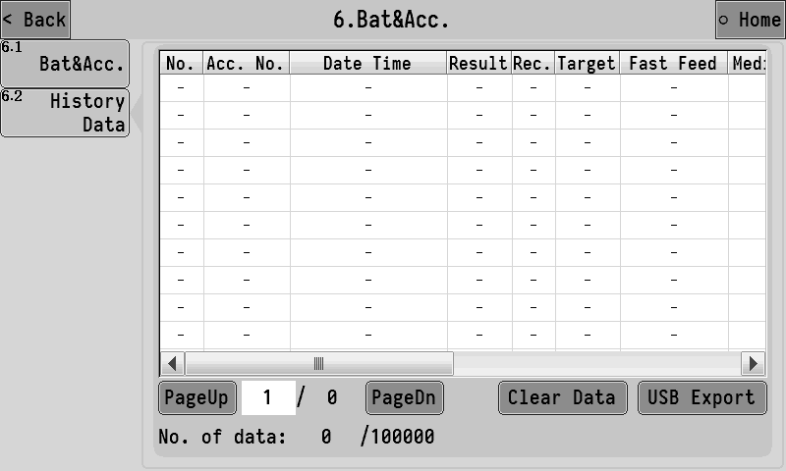

Communications parameters
The controller can be equipped with two completely independent serial communication interfaces, RS232 and RS485, and the communication parameters of the two serial ports can be set respectively.

RS232 Set
Set relevant parameters of RS232 communication serial port.
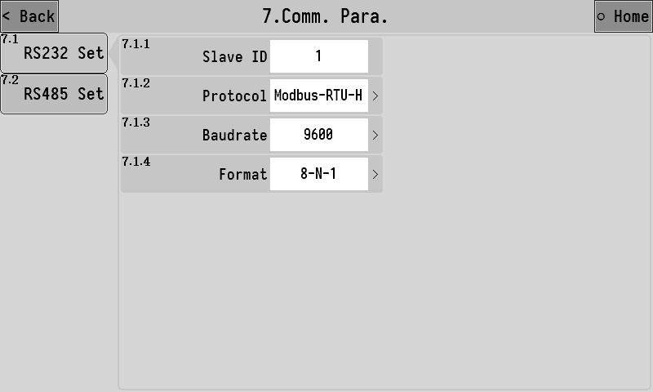
7.1.1 | Slave IO | Set the device's communication address (slave station number).
7.1.2 | Protocol | 1.[Modbus-RTU-H]：Modbus-rtu communication protocol (two-word data with high characters in front).  2.[Modbus-RTU-L]：Modbus-RTU communication protocol (double word data with low word before).
7.1.3 | Baudrate | Set the baud rate for serial communication
7.1.4 | Format | 1.[7-E-1]:7 data bit, parity, 1 stop bit  2.[7-O-1]: 7data bits, odd check, 1 stop bit  3.[8-N-1]:8 data bit, no check, 1 stop bit  4.[8-E-1]:8 data bit, parity, 1 stop bit  5.[8-O-1]:8 Data bit, odd check, 1 stop bit

RS485 Set
Setting method refer to 3.7.1.RS232 setting.

Admin pass-modify
The factory default administrator password is: 000000.The administrator password shall be entered when entering the system maintenance interface
If you need to modify the administrator password, you can enter this interface, enter the new administrator password, enter it twice, and click OK to complete the modification.
If you need to close the administrator password, you can enter the administrator password modification interface without entering any value and directly click confirm twice is OK。
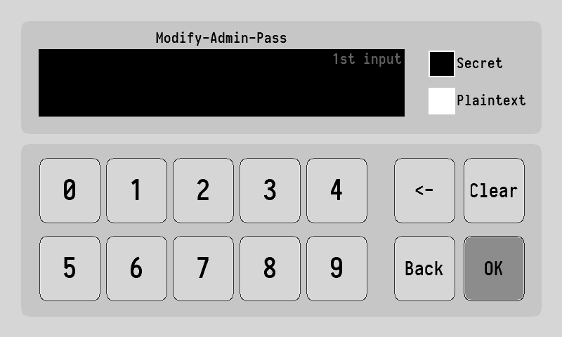

System
System interface contains para reset, date /time, registration, backup/recovery, data import/export.

Para. Reset
Click Reset to reset the corresponding parameter value. The parameter value will be restored to the factory setting. Please operate with caution.
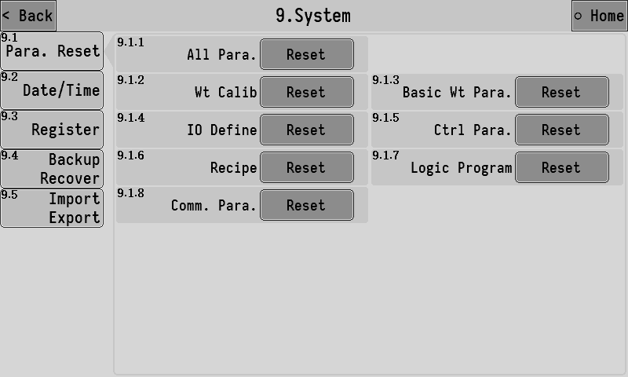

Date /time
The time and date of the controller can be modified.
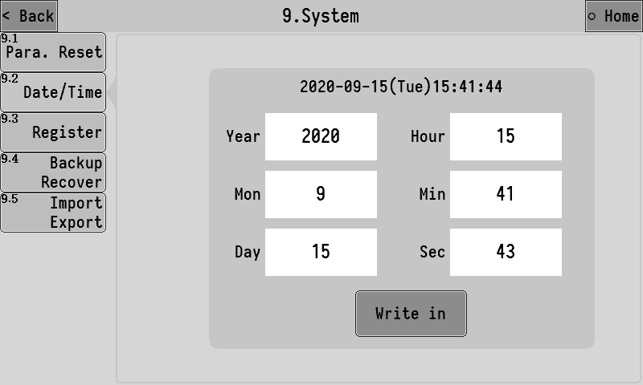

Register
Product usage registration Settings.

Backup Recover
The parameter values currently set by the controller can be backed up to memory in the local machine and can be restored when needed.
The left side can select the parameter items to be backed up, the right side shows whether there is a backup file on the current machine, and the date of the backup file on the current machine is displayed, and the current backup file can be deleted.
To prevent misoperation, when entering the parameter backup and restore interface,default Backup button and Delete the backup button are in the disabled state,Backup and delete functions can only be enabled through special operations. The operation method is to click location three times as shown in the figure below, then click locatio three times, and then click location three times to enable backup and delete functions.
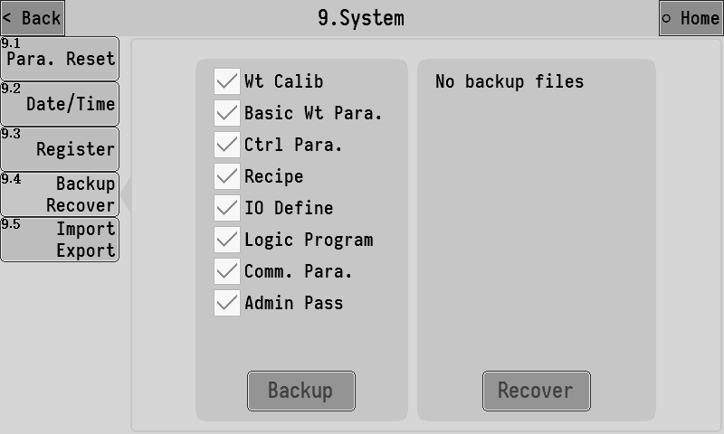

Data import/export
The controller can export the parameters currently set to the usb flash disk, and the export file is in CSV format.
Data export operation:
Select the parameter items to be exported on the left side of the interface. After inserting the USB flash disk, click USB Export to export the selected items to the USB flash disk.
Input import operation:
Insert a USB flash drive with data files, and the list on the right side of the interface will show the data files existing in the current USB flash drive. Select the data files to be imported and clickUSB import. Is ok.
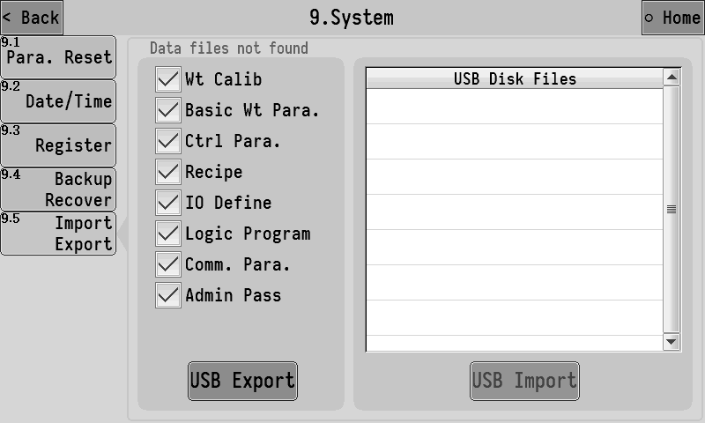

Logic programming
The controller supports 5 logical programming functions. When the controller's existing functions cannot meet the control requirements of the device, it can try to use the logical programming function to define auxiliary logical output signals outside the controller's running process to control the device's actions.
The interface of logical programming setting is as follows: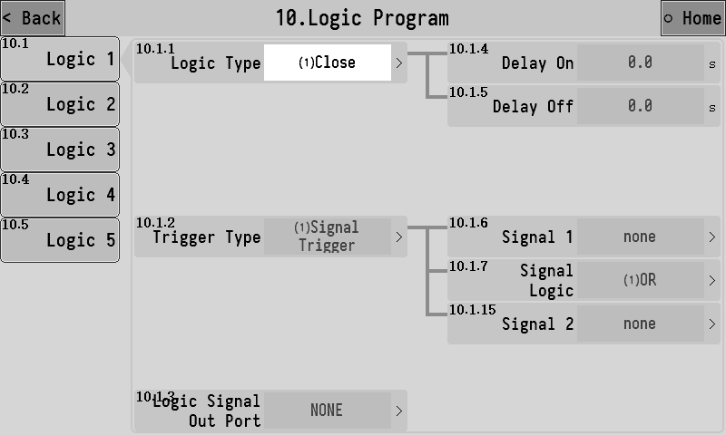
The following is an example of logical programming 1 to explain the role of each parameter.
10.1.1 | Logic type | Select the type of logical programming.  1.[ close]：Turn off the logical output function.  2.[ delay on]  3.[ delay off]  4.[ delay on and delay off]  5.[ off-on edge trigger]  6.[ on-off edge trigger]  7.[ self hold]  8.[ pulse ]  See the corresponding function description for details：3.10.1
10.1.2 | Trigger type | 1.[ signal trigger]：This logical output is triggered by a signal.  2.[ condition trigger]：This logical output is triggered by reaching a certain condition.
10.1.3 | Logical signal output port | Select the logical output signal to define to an OUT outlet.
10.1.4 | Delay time | The time that the logical output signal is delayed on.
10.1.5 | Delayed cutoff time | The time that the logical output signal is delayed and disconnected.
10.1.6 | Trigger signal 1 setting | Select to be the trigger signal 1 of logic output.
10.1.7 | Signal logic | Select the logical relationship between trigger signal 1 and trigger signal 2 used to trigger the logical output.  1.[or]：Trigger signal 1 and trigger signal 2 any valid signal can trigger the logical output.  2.[with]：Trigger signal 1 and trigger signal 2 need to be both valid to trigger the logical output.  3.[xor]：Trigger signal 1 and trigger signal 2 cannot trigger the logical output at the same time.
10.1.8 | Output effective time | 【10.1.1 Logic type】Set to item 5/6 to set this parameter. The effective time of the output after the trigger of the logic signal, and the time to the end of the logical output.When this time is set to 0, the logical output signal will be terminated only by the reset signal.
10.1.9 | Reset signal setting | 【10.1.1 Logic type】Set to item 5/6 to set this parameter. After the logical output is effective, the reset signal can reset the logical output, making the logical output signal invalid and ending the logical output process.
10.1.10 | Reset signal logic | 1.[ Effective reset]：Reset logic output when reset signal is valid.  2.[ Invalid reset]： When the bit signal is invalid, reset the logical output.
10.1.11 | Trigger setting | Select the condition that triggers the logical output.  1.[ The weight is greater than the set value]  2.[ The weight is less than the set value]  3.[ The weight is within the range]  4.[ The weight is outside the range]
10.1.12 | set point 1 | Used to set the weight value of the trigger condition.
10.1.13 | set point 2
10.1.14 | Weight stability condition | 1.[ opened]：The weight meets the set trigger condition, and the logic output cannot be triggered until the weight is stable.  2.[ closed]：The weight meets the set trigger condition and can trigger the logic output without stability.
10.1.15 | Trigger signal 2 setting | Choose to triggers the signal 2 logical output.

Logical output sequence diagram

illustrate
Code function：After the pocket output signal is valid, it will be delayed for 1s, and then output OUT12 will be continued for 2s, which is used to control the coding machine to print the code on the bag after the bag is filled.

The setting is as follows:
【Logic type】：Invalid - valid jump along trigger
【Delay time】：1s
【Output effective time】：2s
【Trigger type】：Signal trigger
【Trigger setting】：Clamp
【Logical signal output port】：OUT12

Through the cooperation of different trigger signals, trigger conditions and 5 groups of logical programming signals, the output of very flexible logic signals can be combined.
For example, the following logic should be implemented: real-time detection of weight higher than 100kg, namely output OUT10 for alarm instruction. When the alarm is effective, it will delay 2s and output OUT11 lasts 3s to control the discharging mechanism to discharge the materials.
The setting is as follows:
Logic programming 1：The test weight above 100kg is output OUT10。
【Logic type】：Delay on
【Delay time】：0s
【Trigger type】：Condition triggered
【Trigger setting】：The weight is greater than the set value
【set point 1】：100kg
【Logical signal output port】：OUT10
Logic programming 2：When OUT10 is effective, it will delay 2s and output OUT11 will last 3s.
【Logic type】：Invalid - valid jump along trigger
【Delay time】：2s
【Output effective time】：3s
【Trigger type】：Signal trigger
【Trigger setting】：Logical output 1
【Logical signal output port】：OUT11

Instructions of Process

Process of weighing ton package
The basic packaging process of weighing scales with bucket will be explained in combination with the above figure:
- Start running.
- Wait for the bag clamping and hook completion,and the bracket will rise .
- After the end of the mounting, delay before starting feeding, and stable peeling after the end of the delay (for the net package, no peeling for the gross package).
- After successfully removing the skin, open the large feed ,when the weight value≥target value -leading quantity of fast feeding, close fast feeding, open moderate feeding.
- When the weight value≥target value-leading quantity of moderate feeding, close moderate feeding and open slow feeding.
- When the weight value≥target value-slow feeding drop in level number ,close slow feeding and end feeding ,start fixed value and hold time.
- If the bagging function is turned on during feeding, the bagging action will be performed simultaneously during feeding.
- After the maintenance time of the fixed value is over, the weight of feeding shall be recorded, and it shall be judged whether to carry out overbalance detection and drop correction according to the setting of control parameters
- The bracket descend.
- Loose the bag and unhook the bag according to the setting of control parameters.
- If the control function of the conveyor is turned on after the lowering of the support, the signal of the output conveyor controls the conveyor to carry away the packaging bag.
- Complete the first packaging process and return to step 1 to start a new packaging process.
note：
① Bracket lifting control：Detailed control parameters are set in Section 3.3.2.
【3.2.1 lift stents ctrl mode】The process of “air infinite” is：
Stent rising process：The output signal of switching volume "Q13 rising (pneumatic)" is effective, and the bracket begins to rise. After setting [3.2.2 rising time], the bracket is considered to have finished rising.
Stent descent process：The output of switch output signal "Q13 rising (pneumatic)" is invalid, and the support begins to fall. After setting [3.2.3 falling time], the support is considered to have finished falling.
【3.2.1 lift stents ctrl mode】The process of “Electric - double limit”is：
Stent rising process：The output signal of the switching volume "Q14 rise (electric)" is effective, and the support begins to rise. When the input signal of the switching volume "I18 support upper limit" is effective, the output of the output signal of the switching volume "Q14 rise (electric)" is invalid, and the support is considered to have finished rising.
Stent descent process：When the output signal of the switching volume "Q15 drop (electric)" is effective, the support begins to drop. When the input signal of the switching volume "I19 upper limit of the support" is effective, the output of the output signal of the switching volume "Q15 drop (electric)" is invalid, and the support is considered to have finished its decline.
【3.2.1 lift stents ctrl mode】The process of “Pneumatic - double limit”is
Stent rising process：The output signal of switching volume "Q13 rising (pneumatic)" is effective, and the support begins to rise. When the input signal of switching volume "I18 upper limit of support" is effective, the support is considered to have finished rising.
Stent descent process：The output of "Q13 rising (pneumatic)" of the output signal of switching volume is invalid, and the support begins to fall. When the input signal of "I19 upper limit of the support" is effective, the support is considered to have finished falling.
② Bag Function：Detailed control parameters are set in Section 3.3.5.
③ error detection and error correction：Detailed control parameters are set in Section 3.3.6 .
④ Bag Function：Detailed control parameters are set in Section 3.3.7.

Stop,pause and slow stop
After the stop signal is input, the controller will immediately shut down the feeding related output signal and enter the stop state. After starting again, the packaging process will be resumed.
After the pause signal input, the controller will immediately shut down the feeding related output signal and enter the pause state. The user can choose to start again or enter the stop state. After the restart, the state before the pause will continue to start the packaging process.
After the stop signal is input, the controller will stop after completing the packaging process.

AMC501-T-920B1
BKG:2020.08.13

